In the quantitative data analysis, correlation analysis and regression analysis were conducted with government effectiveness as the independent variable and renewable energy adoption as the dependent variable. In addition to these variables, GDP per capita, CO2 emissions, and energy use are included as control variables.
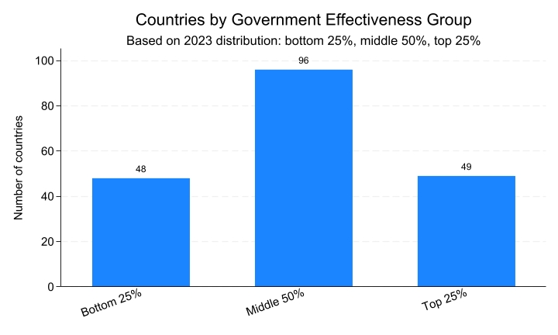
Figure 1. Countries by Government Effectiveness Group
Countries were classified into three groups based on the distribution of government effectiveness scores as the bottom 25%, the middle 50%, and the top 25%. This approach provides a clearer distinction between relatively weak and strong government effectiveness than a simple median split.
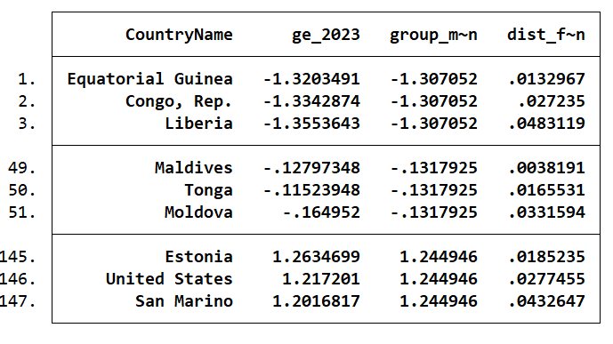
Table 1. Government effectiveness figures by quintile
Representative countries were selected as the three countries closest to the mean government effectiveness score within each group. For the bottom group, the representative countries were Equatorial Guinea, Congo, and Liberia. For the middle group, they were Maldives, Tonga, and Moldova. For the top group, they were Estonia, the United States, and San Marino. The average score of the bottom group was -1.307052. Since the selected countries were very close to this value, they can be considered typical cases of low government effectiveness. This suggests that countries in the bottom 25% generally had government effectiveness scores of around -1.31. The average score of the middle group was -0.1317925. As these countries were also close to the group mean, they can be seen as typical examples of countries with moderate government effectiveness. Overall, the middle 50% were neither especially high nor especially low, but were concentrated around a level close to zero, though still slightly negative. The average score of the top group was 1.244946. These countries were closest to the mean of that group and therefore represent typical examples of high government effectiveness. Overall, the top 25% of countries showed a relatively high level of government effectiveness, at around 1.24.
At first, the dataset was going to be organised using 2023. However, the data for renewable energy adoption, CO2 emissions, and energy use were not available for many countries in that year. Because of this, the whole sample was deleted during the cleaning process. To solve this problem, the dataset was rebuilt using 2018, which was the most recent year where all the main variables, including GDP per capita, were available together. This made it possible to create one complete country-level dataset for the analysis.
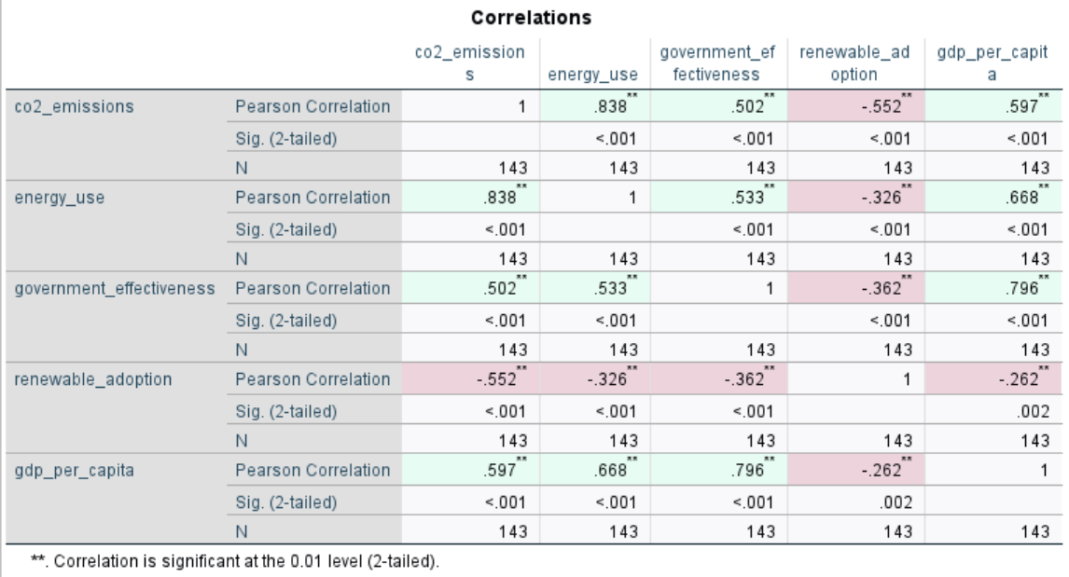
Table 2. Pearson Correlation Matrix of Government Effectiveness, Renewable Adoption, GDP per Capita, CO2 Emissions, and Energy Use
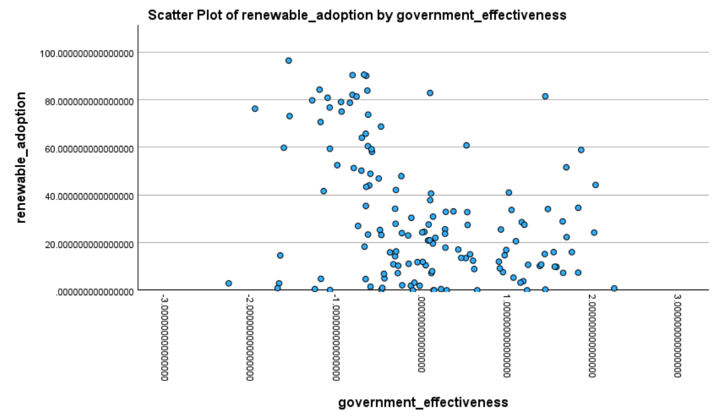
Figure 2. Scatter Plot of Renewable Adoption and Government Effectiveness
Using the new 2018 dataset, the scatter plot and the correlation table show that the relationship between government effectiveness and renewable adoption is negative, not positive. The Pearson correlation coefficient is -0.362, and this result is statistically significant at the 1% level. This means that, in this sample, countries with higher government effectiveness tended to have lower renewable adoption. The scatter plot also shows this pattern. It does not show a clear upward trend, and overall, it suggests a weak negative relationship. However, this result should be interpreted carefully. It does not mean that better government effectiveness directly reduces renewable energy adoption. Instead, it may show the nature of the renewable adoption indicator and differences in countries’ development levels and energy structures. In particular, this indicator may reflect not only modern renewable energy use, but also broader energy consumption patterns, which can be very different between high-income and low-income countries. Since correlation analysis only shows the relationship between two variables, it cannot tell us whether government effectiveness still matters when other factors are considered. For this reason, regression analysis was carried out. Renewable adoption was used as the dependent variable, government effectiveness was used as the main independent variable, and GDP per capita, CO2 emissions, and energy use were added as control variables.
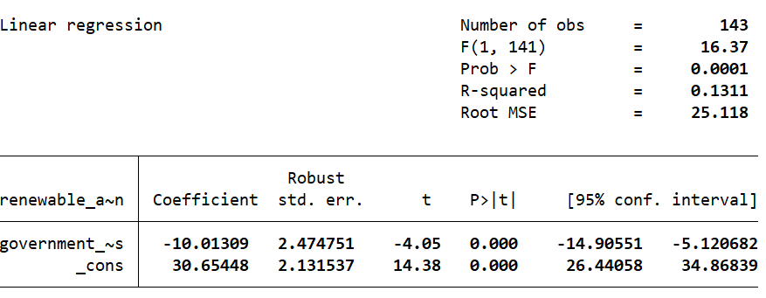
Table 3. Regression Results for Renewable Adoption, Model 1
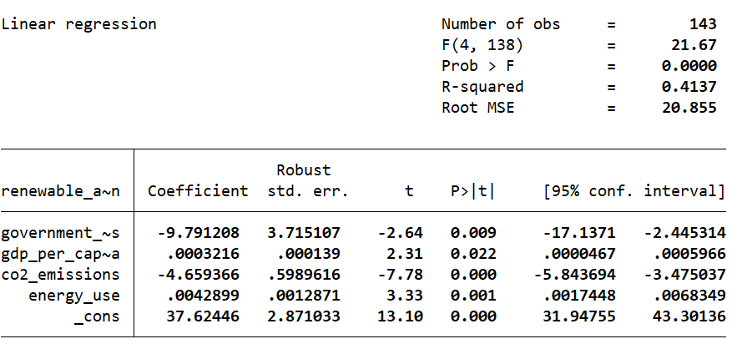
Table 4. Regression Results for Renewable Adoption, Model 2
Regression analysis was conducted to examine whether the negative relationship between government effectiveness and renewable adoption remained after controlling for other factors. In Model 1, government effectiveness showed a statistically significant negative association with renewable adoption, with a coefficient of -10.013. In Model 2, after adding GDP per capita, CO2 emissions, and energy use as control variables, the coefficient of government effectiveness remained negative and significant at -9.791. This suggests that the observed negative relationship was not explained only by differences in income, emissions, or energy use. In addition, GDP per capita and energy use were positively associated with renewable adoption, while CO2 emissions showed a significant negative relationship. The explanatory power of the model also improved substantially, as the R-squared increased from 0.131 in Model 1 to 0.414 in Model 2.
Overall, the quantitative analysis shows that government effectiveness was negatively associated with renewable adoption in this sample. This pattern appeared in both the correlation analysis and the regression models, and it remained significant even after controlling for GDP per capita, CO2 emissions, and energy use. However, this result should be interpreted carefully, as it may reflect differences in countries’ development levels and energy structures rather than a direct causal effect of government effectiveness. Therefore, the findings suggest that the relationship between government effectiveness and renewable adoption is more complex than originally expected.

